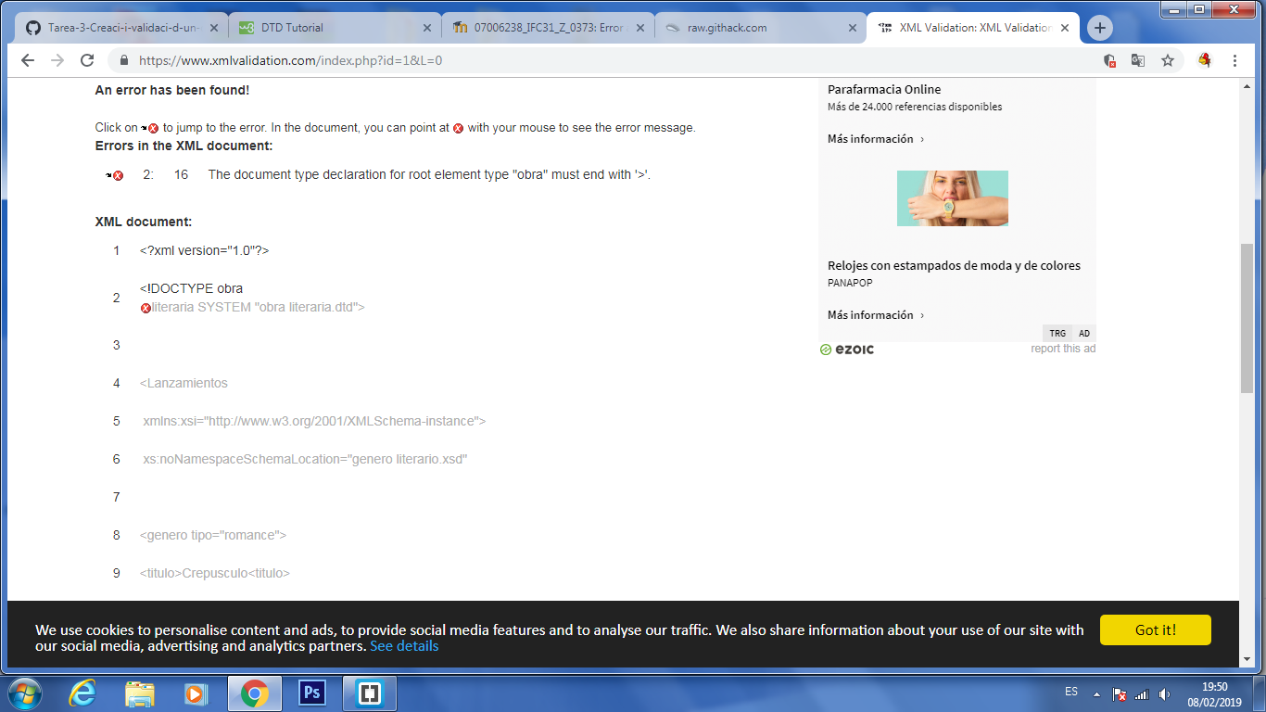
https://www.xmlvalidation.com/

